**Model Development Phase**

**Initial Training Code :**

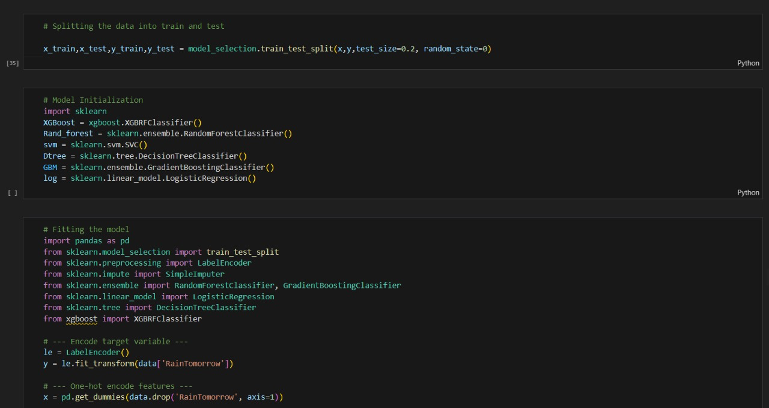

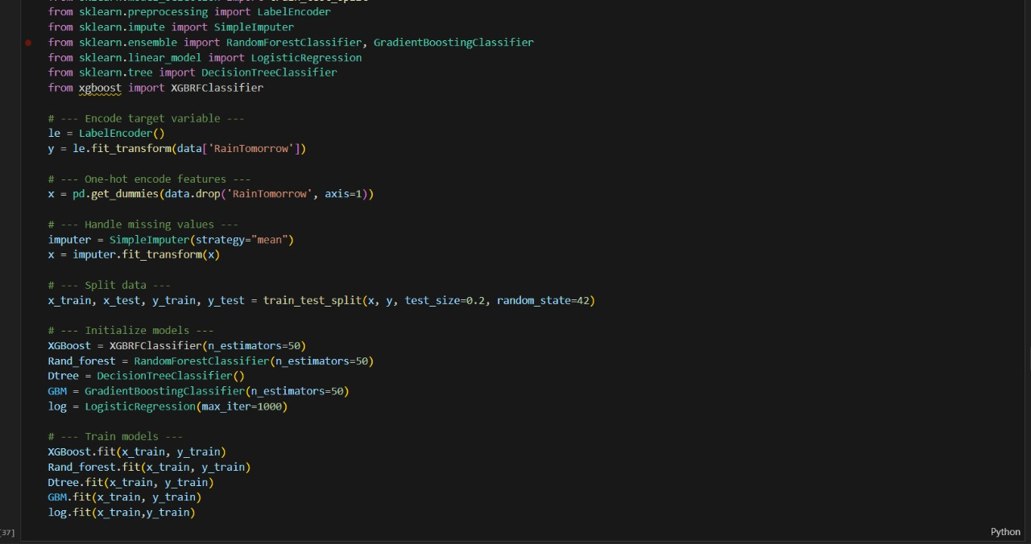

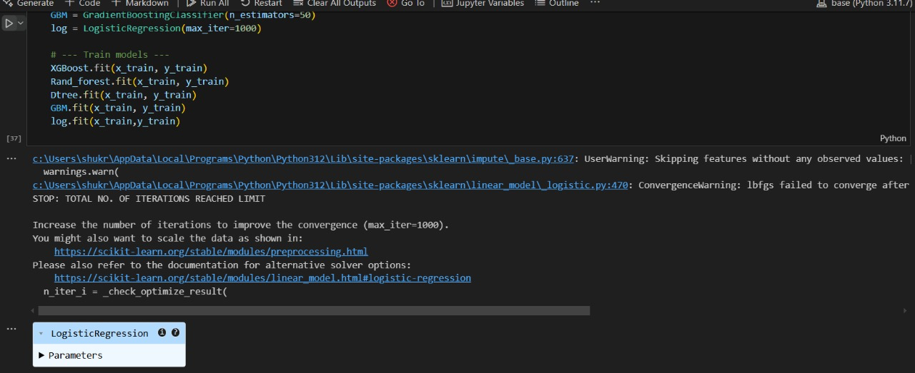

**Model Evaluation and Validation Report :**

* **Accuracy Score**

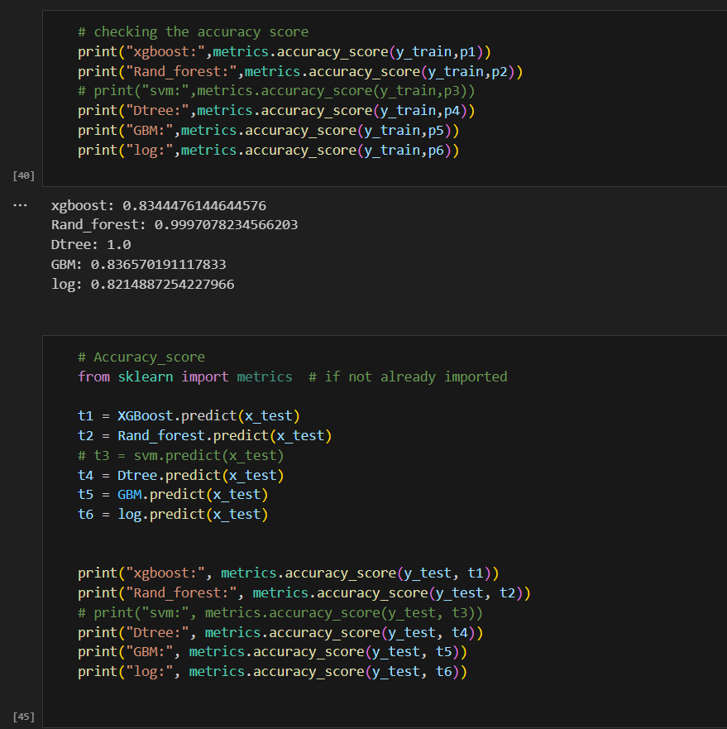

**xgboost: 0.8252096796370136**

**Rand_forest: 0.8323594115220679**

**Dtree: 0.7958545304551079**

**GBM: 0.8327031486319263**

**log: 0.8202254915440671**

* **Confusion Matrix**

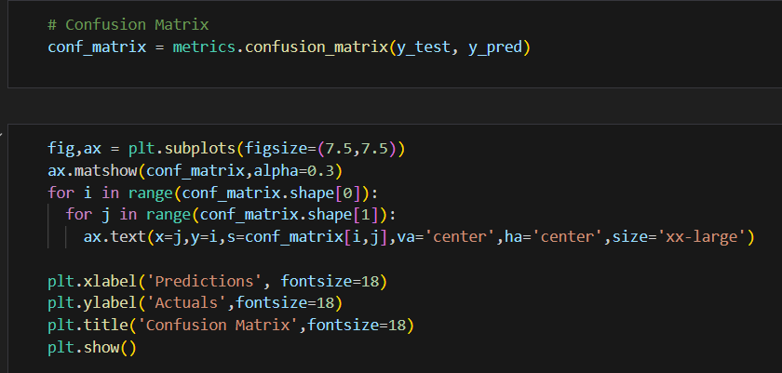

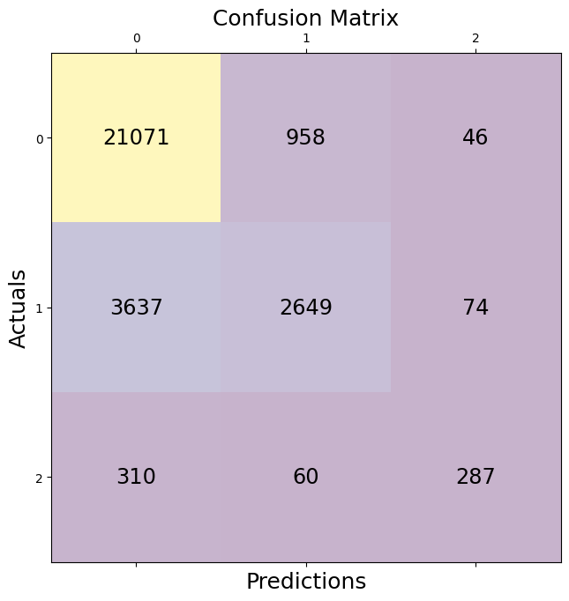

**Save The Model:**

* **Model is saved using pickle**

